# LESA Parser

On windows, open cmd window from the folder containing the parser “lesa_xml_parser.exe”.



Where,

Argument 1: lesa_xml_parser is the name of the function

Argument 2: “C:\Users\......\xml\*.xml” is the folder where all the xml files are located.

Argument 3: x value

Argument 4: y value

Argument 5: orientation left or right

Once you run the command, you should see a logo pop-up and the following in the command window:

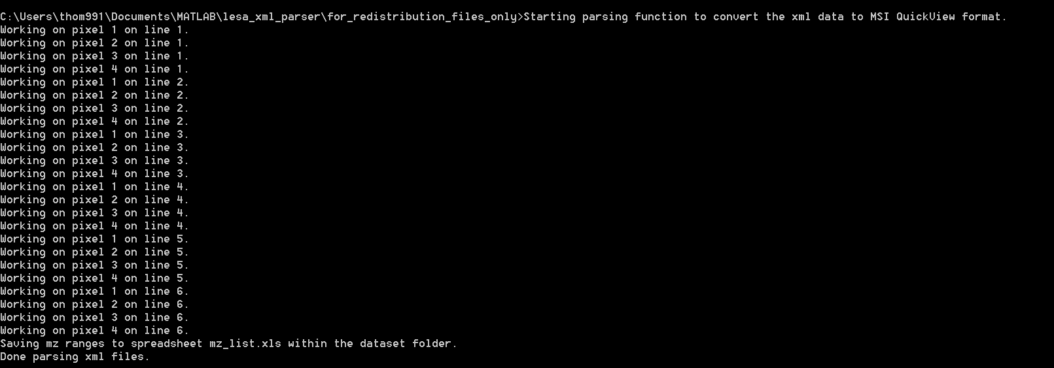

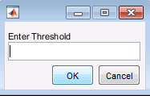

Threshold value will determine the range (lower to upper) of m/z values in the excel sheet. For e.g., threshold of 0.5 will mean that lower m/z might be 101.1, then anything up to 101.6 will fall within the range.

Once the parsing is complete, the folder containing the xml files should look like the following:

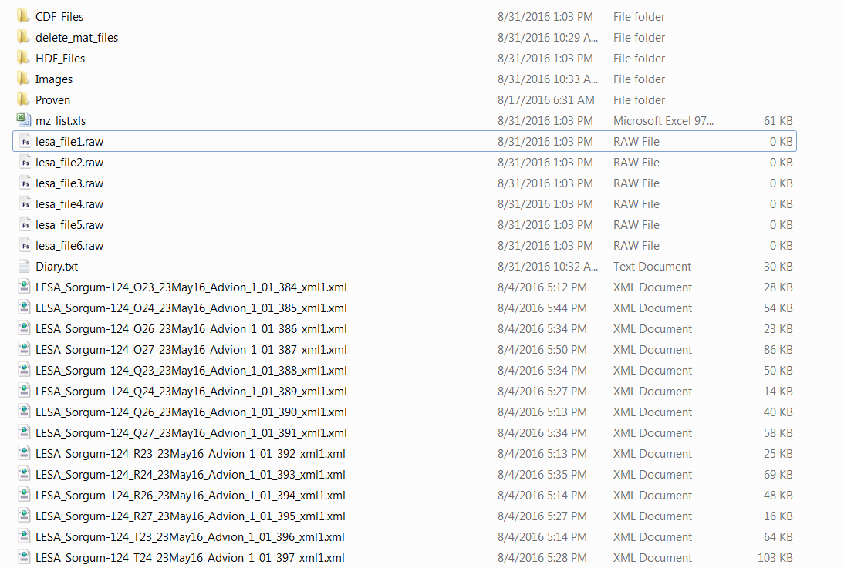

CDF_Files, HDF_Files and the raw files are required to run MSI QuickView.

mz_list.xls is also generated with m/z range values for the dataset.

# MSI QuickView

1. Open “MSI_QuickView.exe”

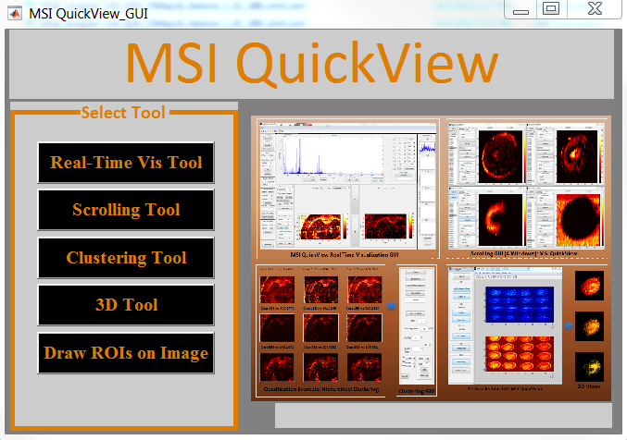

1. Select “Real-Time Vis Tool”

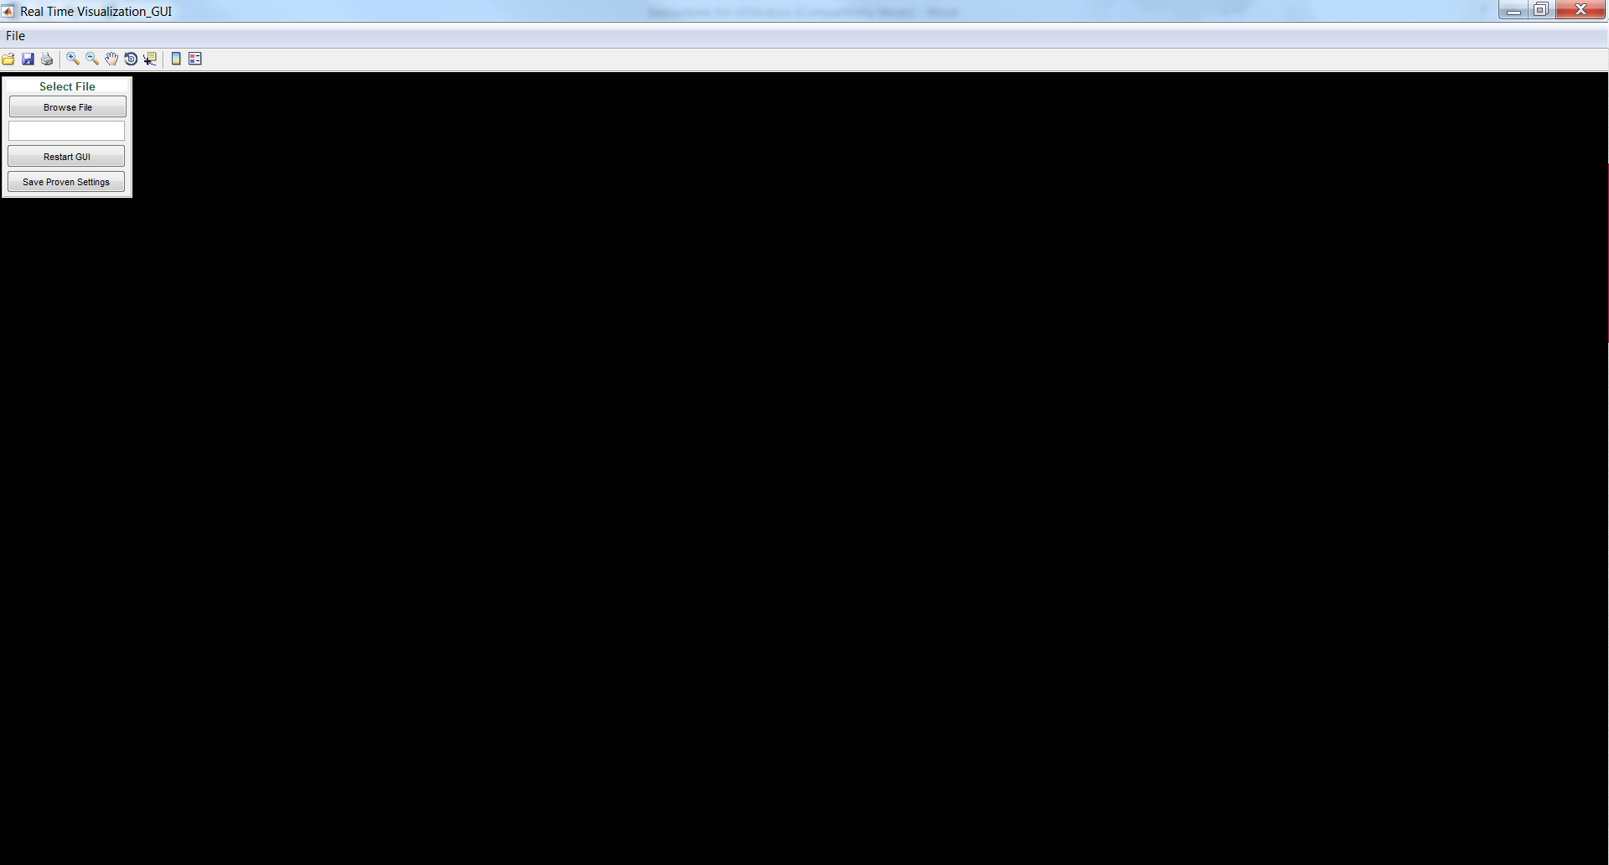

1. Select “Browse File” option
   1. Hit “O.K.” button to leave default provenance info, will modify as needed later on.
   2. Hit “O.K.” button for notes window as well.

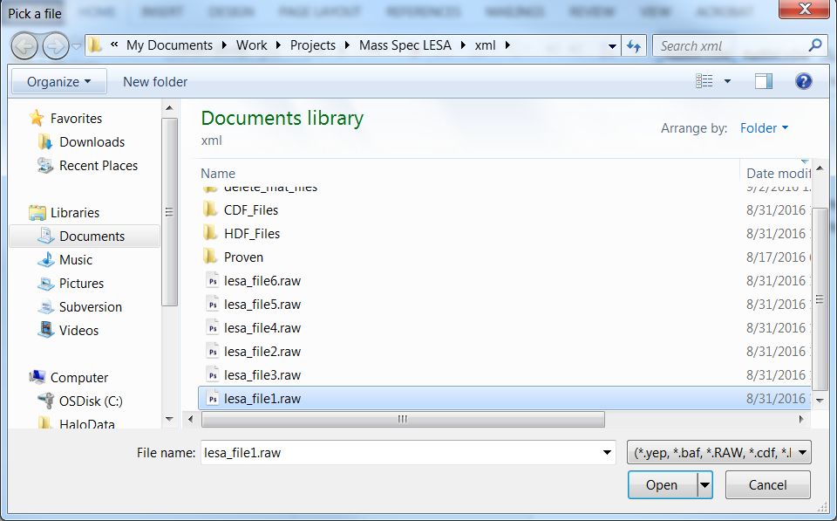

* 1. Pick the first raw file and select “Open”

1. a. Enter the Image Aspect Ratio (orange box), example 12 across (width of image) and 6 down (height of image) and select “Enter”

b. You can see the number of raw files/lines in the dataset (blue box). Select “Start” button and select “Yes” to use default m/z range.

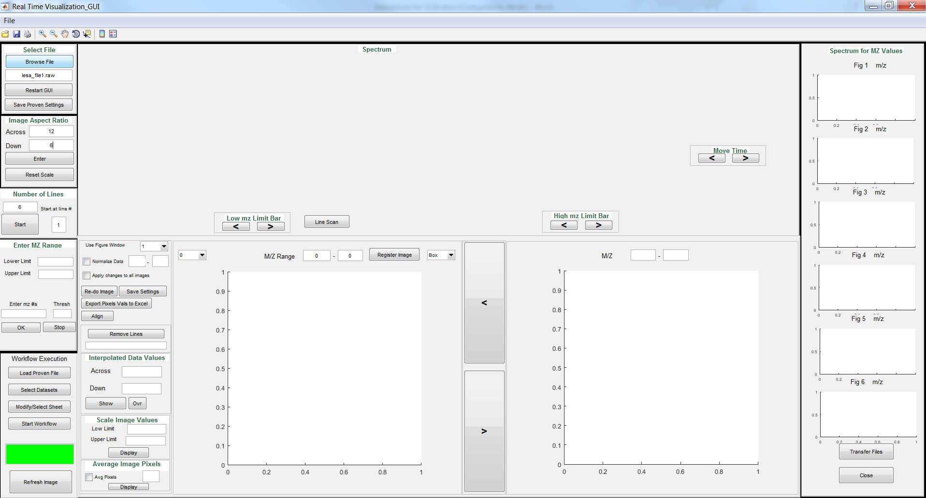

This will start populating the data in the UI.

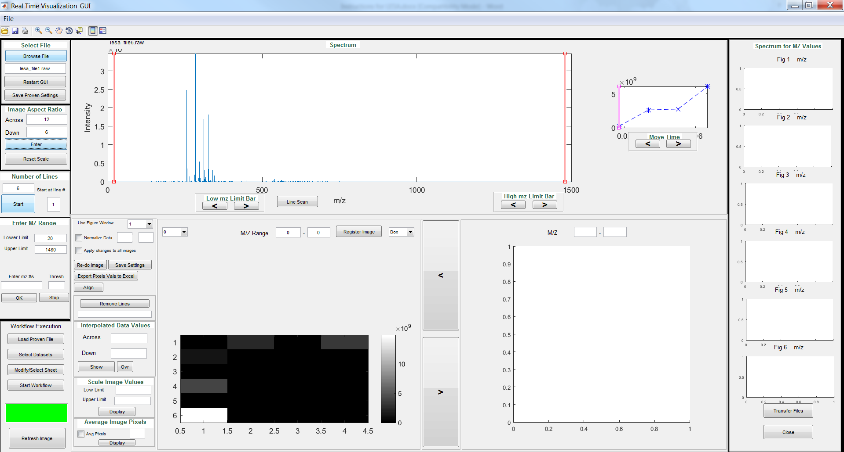

To change the colormap, select the “Close” button.

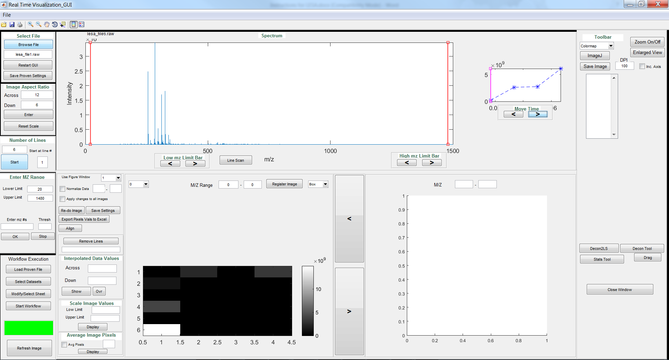

Select an option from the “Colormap” drop-down list, e.g., Parula

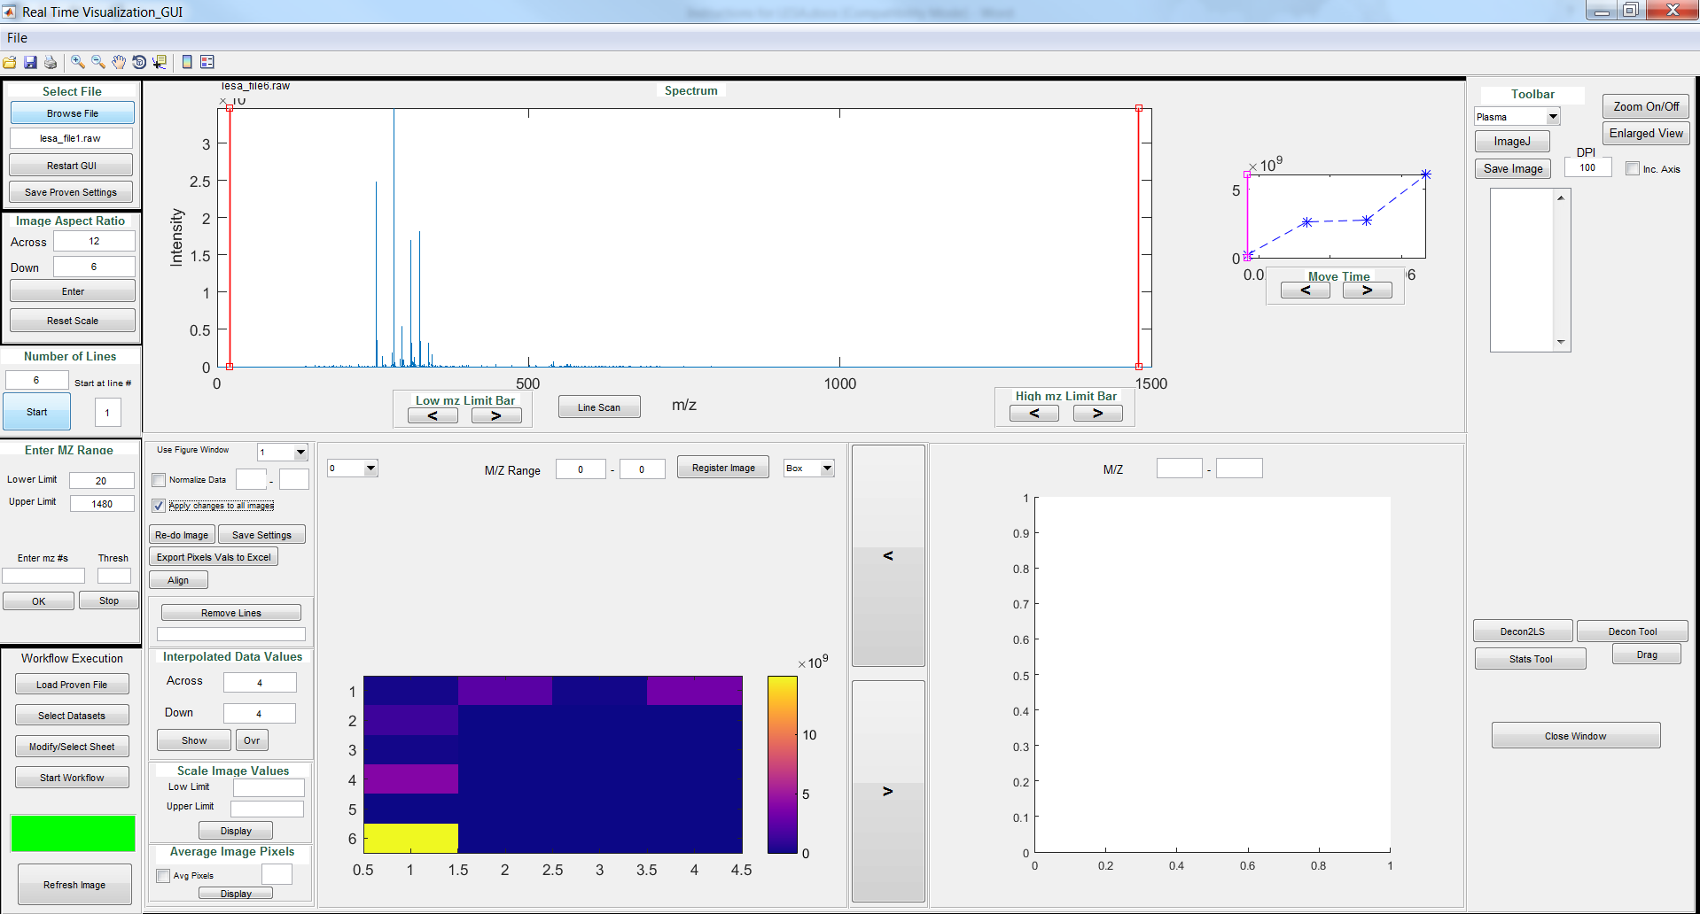

Select “Apply to all images” and enter interpolation values “Across” and “Down” to smooth out images. Select “Re-do Image” and select the xls file containing list of m/z values saved from the LESA file conversion. Fill out the following fields and the images will be saved into the Images folder within the dataset.

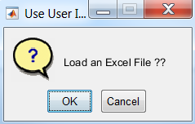

Hit “Ok”

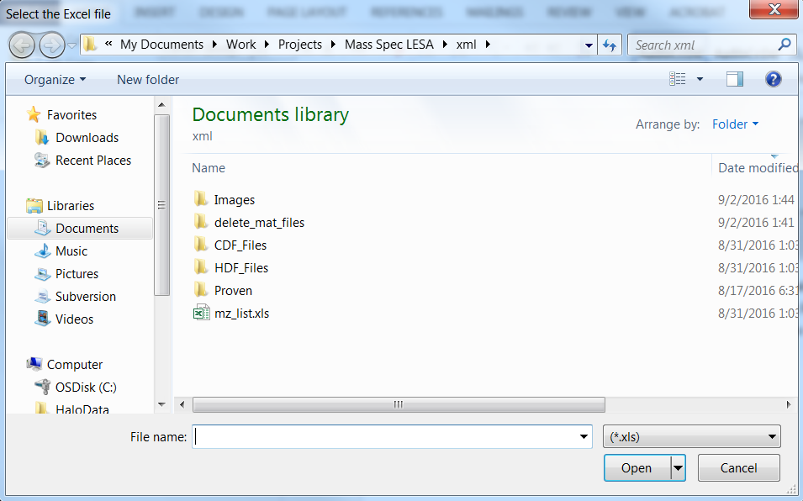

Select the xls file

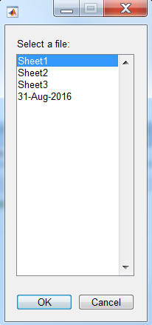

Select the right sheet, e.g., 31-Aug-2016

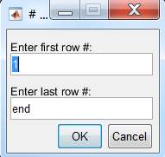

Select lower and upper number for number of images to generate. By default, end will mean that images are generated for all of the mz ranges.

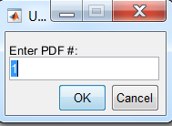

Enter pdf# to save all of the images to.

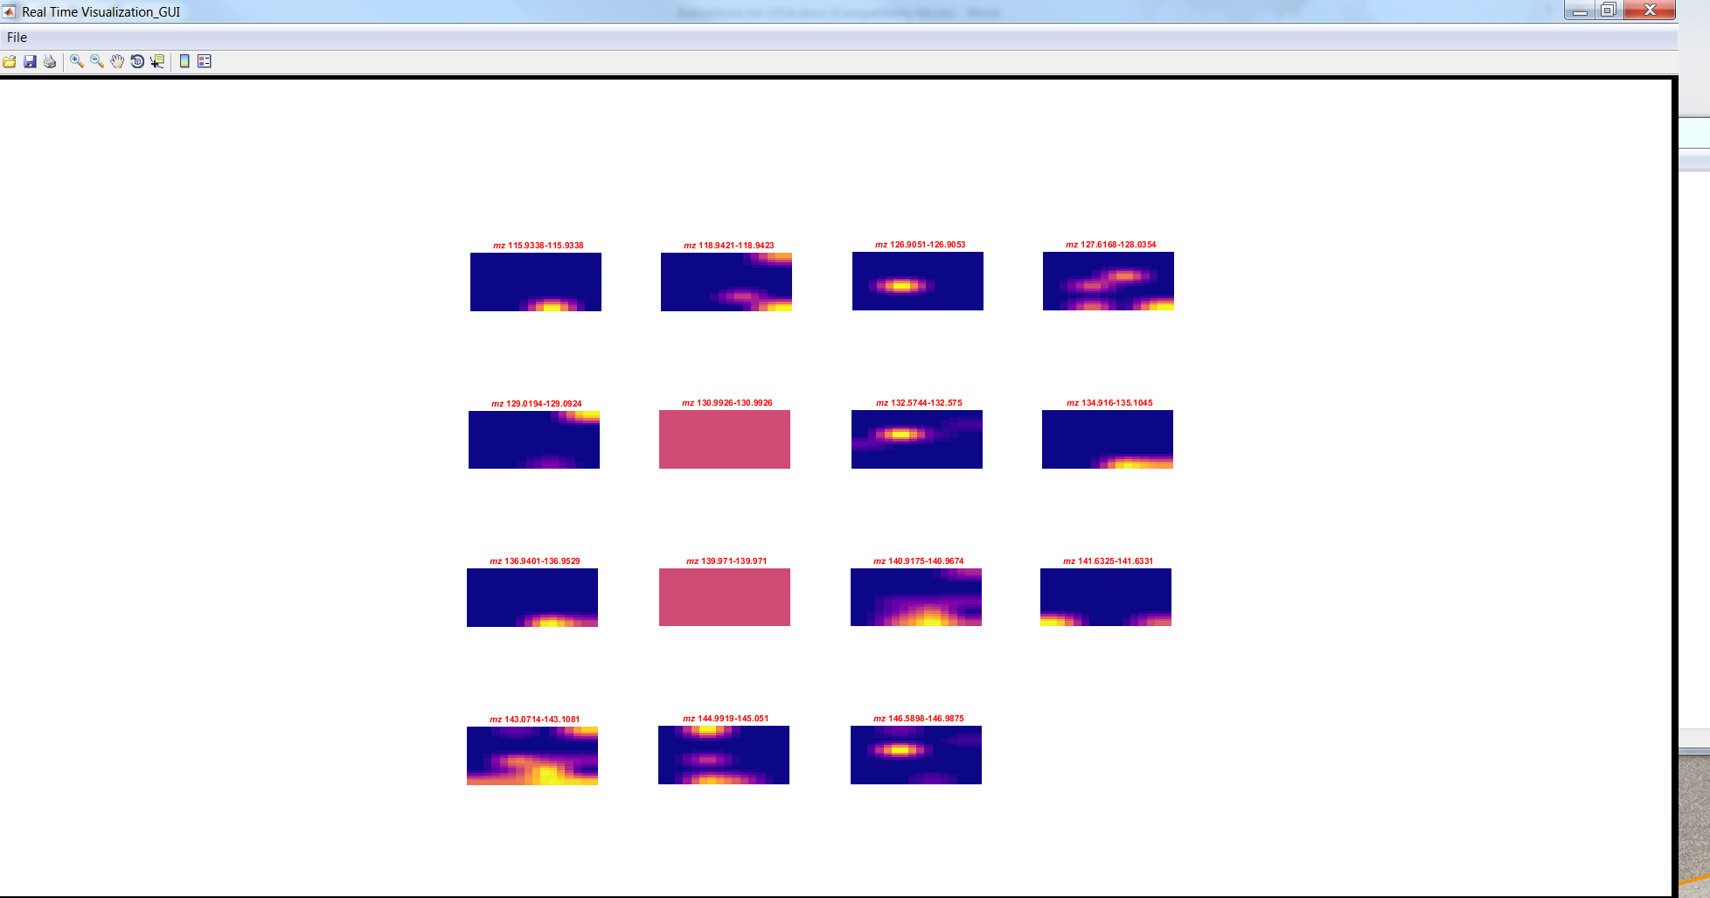

You will see the images being generated.

Once all images are generated, MSI QuickView will return to its default page:

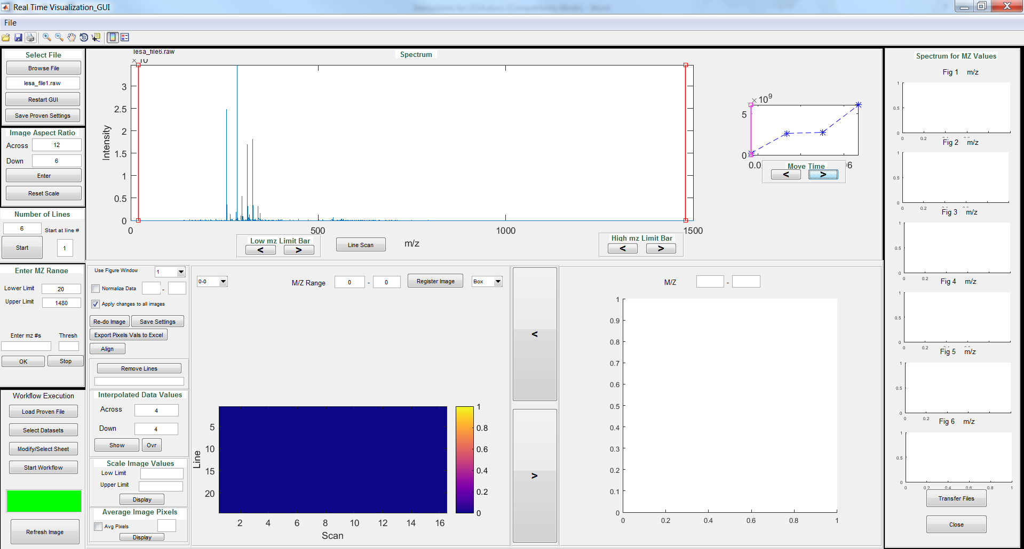

Now you can hit < and > symbols to scroll through the images. Hit “Close” button and you can see the list of images. Select the images you wish to save and hit “Save Image”. You can select “Inc Axis” if you want to save the axis.

